Ex. No.:3 Date: 28/08/2020

**Steady state AC analysis of an AC series circuit** consisting of

Resistor – Capacitor load  
Resistor –Inductor load  
Resistor-Inductor-Capacitor load

Aim:

To find the current in the series circuit consisting of the following loads –

1. Resistor- Capacitor (R-C) load
2. Resistor – Inductor (R-L) load
3. Resistor – Inductor – capacitor (R-L-C) load

Apparatus/Tool required:

ORCAD / Capture CIS --> Analog Library – R, C, L

Source Library – Vac &

Ground (GND) – 0 (zero)

Simulation Settings: Analysis Type – AC Sweep (1Hz to 10kHz)

R = 200Ω, C = 47µF, L = 47mH, AC source voltage = 20V, ω = 500 rad/s

a) R-C load

Circuit Diagram

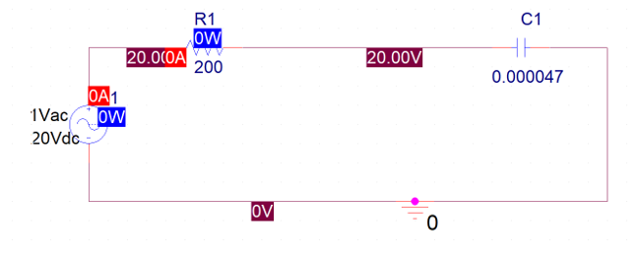

Simulated Result:  
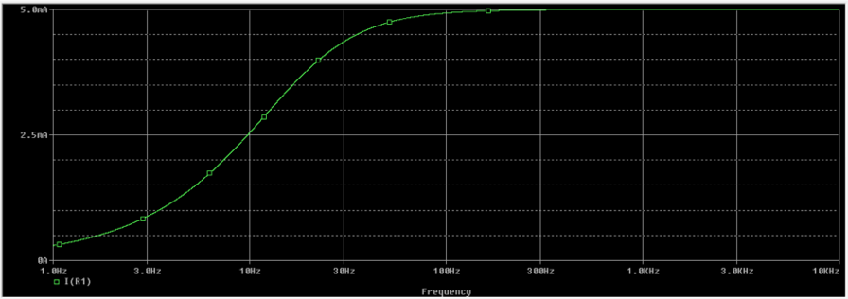

Manual calculations: ZC, I

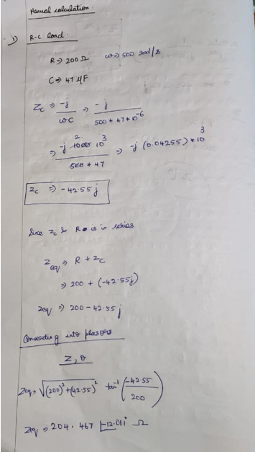  
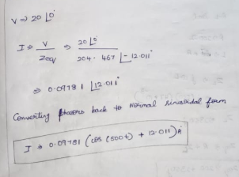

b)R-L load

Circuit Diagram

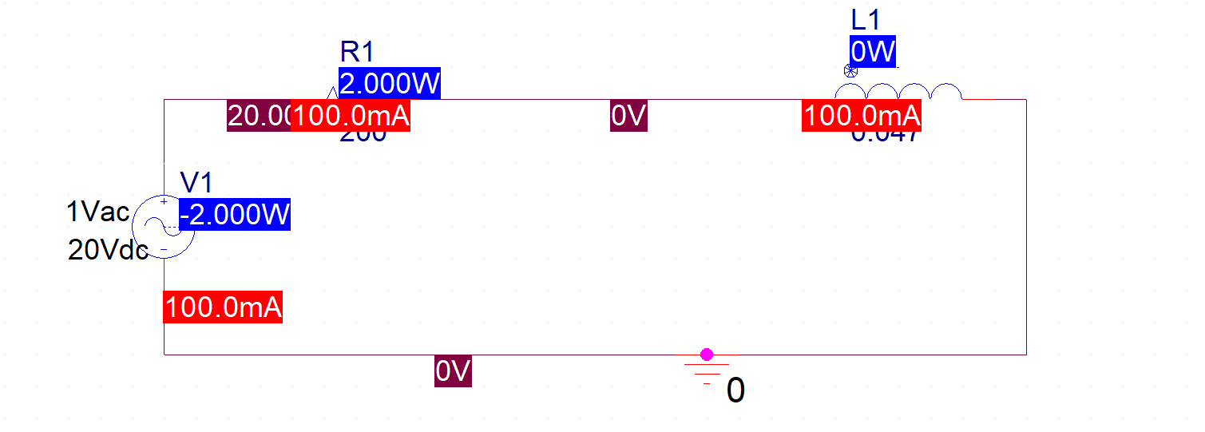

Simulated Result:

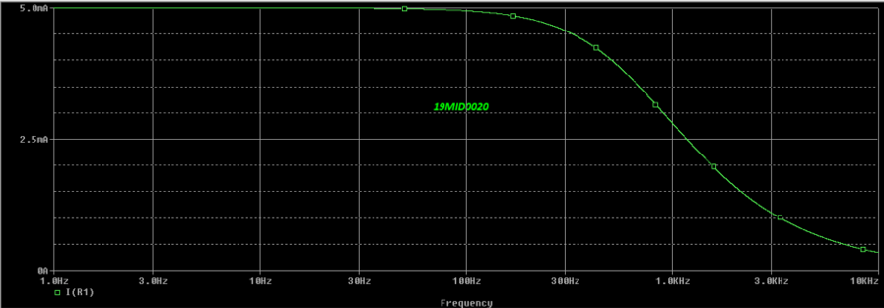

Manual calculations: ZL, I

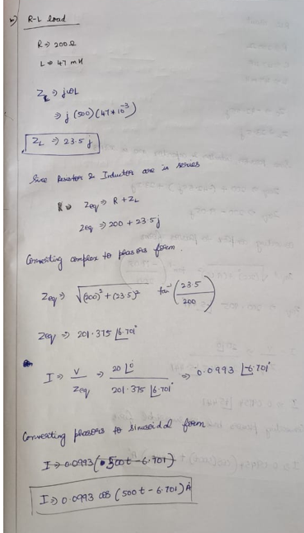

c)R-L-C load

Circuit Diagram

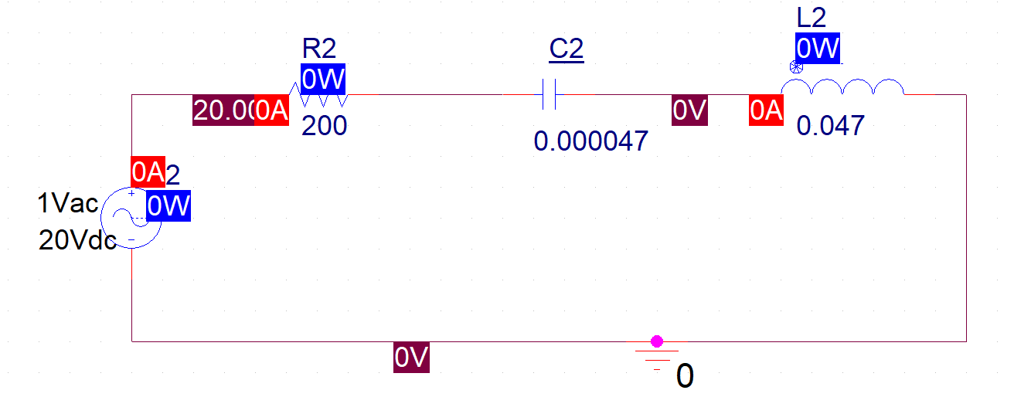

Simulated Result:

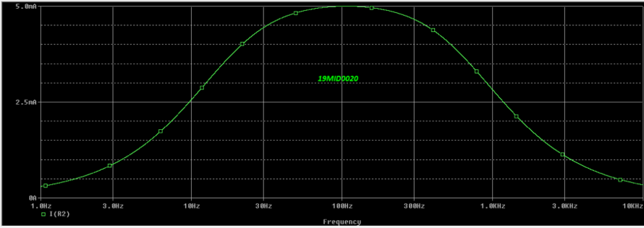

Manual calculations: ZC , ZL, I

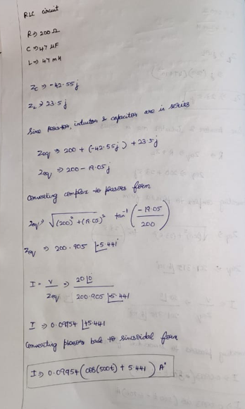­

**Inference:**

The graph of RC load has positive slope as Capacitor accumulates and stores charges (charging).

The graph of RL load has negative slope as Inductor is an insulator and it loses charge (discharging).

The slope of graph increases in the first half and decreases in the next half. It looks like normal curve

**Reg. No: 19MID0020 Name:Prashanth.S Date: 28.08.2020**